**Comparing mean-reversion to momentum moving average investment strategies**

# Introduction

This study will explore how moving average investment strategies performs compared to the index, and especially how transaction costs and rebalancing frequencies impacts the performance. Moving average strategies have for a long time been a very used strategy within investment management, but a high rebalancing frequency can easily dilute the performance due to transaction costs increasing with rebalancing frequency. There might exist an optimal rebalancing frequency which aims to optimize the risk-reward of the strategy and rebalancing frequency.

Three moving average strategies will be compared in this study:

* A mean-reversion model with a fixed rebalancing frequency
* A momentum cross-over strategy
* The golden/dead cross strategy

In order to measure the probability of choosing a strategy which can yield sustainable alpha, each strategy is measured using the average cumulative performance, across all investment opportunities within the strategy. For the mean-reverting model with fixed rebalancing frequency the investor needs to choose a specific moving-average period to calculate the moving-average stock price, and also choose how often the strategy should be rebalanced. A table will be created with the performance of all possible strategies within the universe of 1-90 days rebalancing frequency and 10-200 days moving-average price. A heatmap is then used to visualize the performance across all strategies and identify potential tendencies in the output which can be used to narrow down the universe of possibilities for the investor. Utilizing such a framework will hopefully prove to narrow down the universe to a manageable amount of investment opportunities which on average will yield alpha.

If the average cumulative performance across a set of strategies is positive, the investor have the theoretical possibility to invest 1/n in each strategy and generate alpha. From a practical point of view, the investment universe will then need to be quite narrow in order for any investor to keep track of all strategies within the portfolio.

The momentum cross-over strategy is evaluated using the same methodology. For this strategy there is only one input variable which is the number of days used to calculate the moving average price. The strategy is evaluated using a range of 1-200 days. The reason the number of days already begins with 1 and not 10, is that this is a momentum strategy which may be deployed using a very short time horizon, whereas a mean-reversion model such as the first model, is usually deployed using a bit longer time-horizon.

The golden/dead cross strategy is evaluated using the same methodology as the previous two models.

The three strategies is then evaluated across different scenarios with and without short selling allowed and at different assumptions regarding trading costs for rebalancing the portfolio.

At the end, the strategies are also being compared to each other in order to capture any tendencies which will be evident from the test results. The average cumulative performance is used as a measure for best chances of sustainable alpha.

In order to perform the study, data is gathered from the website [www.Investing.com](http://www.Investing.com) where historical time series on quotes for the Stoxx 600 is publicly available. Publicly available data is limited to 8 years, why the data used will be from 2013-2021. This analysis does not consider potential impacts on the outcome if the time series had been from a different point in time with different economic conditions.

The logic applied for the data model and investment strategy includes end of day prices being used. In order to capture the return on day t, you would need to hold the stock from closing on day t-1 to closing on day t. In a moving-average strategy, in order to capture day t’s return, you would need to have been long on day t-1 as the trade is assumed to take place at end of day.

# A mean-reverting model with fixed rebalancing frequency

The test result figures shows a heatmap of the cumulative performance on the Stoxx600 index from 2013 to 2021 using a moving average trading strategy with different moving average prices (along the x axis) and different rebalancing frequencies (along the y axis). The strategy is assuming mean-reversion, instead of price momentum, which usually indicate trading signals in a moving average strategy. As such, the position taken at the rebalancing dates is long when the index price is below the moving average price, and neutral when the index price is above the moving average price. If position is changed at the rebalancing date, trading costs of 20 bps is assumed.

As data is limited to 8 years, using a higher moving average frequency, means that the time series will get shortened. If a 200 day moving average needs to be calculated before the strategy can be initially evaluated and traded on, only 7 years of price data remains. The result of this analysis can be impacted by the strategy performing better in a specific market environment which is present to a larger extend given the shortened time series due to the moving average frequency. This is especially true because of the relatively short time series being analysed.

## Test results

As it can be seen from figure 1, there is no clear tendency in the data output which could lead to sustainable alpha. There might be a slight tendency for better performance using rebalancing below every 30th day compared to above every 30th day. The average cumulative alpha across all strategies is -19,53% with a standard deviation of 24,90%. The probability of landing a strategy with positive added value is low, and with no clear tendency in the data, implementing a strategy which ends up adding value is probability more due to luck than skill. This test result is based on an assumption of 20bps in rebalancing trading costs and short selling not allowed. If the test is being performed without assuming any trading costs, the average cumulative performance improves from -19,53% to -11,42% with a standard deviation of 26,58%. As visible from figure 1 and 2, no clear tendencies emerges when removing the transaction costs.

Assuming 20bps in trading costs but the position turning short instead of neutral when the observed price is above the moving average price does not seem to yield better results. The average cumulative performance across all strategies is -41,13% with a standard deviation of 42,80%. There continues to be a slight tendency for better performance when keeping the rebalancing below every 30th day as shown in figure 7.

Continuing from the previous example with taking a short position, as opposed to neutral, when the observed price is above the moving average price, and assuming no trading costs, still does not seem to be yielding better results. The average cumulative performance across all strategies is -33,99% with a standard deviation of 46,19%. There continues to be a slight tendency for better performance when keeping the rebalancing below every 30th day as shown in figure 8.

It is worth noting that the potential value added is higher with short selling allowed, however the risk, measured by standard deviation, is accordingly higher and the probability of choosing a strategy with sustainable alpha is lower as measured by the average cumulative performance.

Figure 1: 20bps trading costs and shorting not allowed

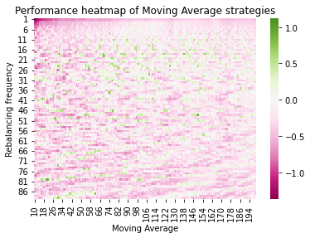

Figure 2: No trading costs and shorting not allowed

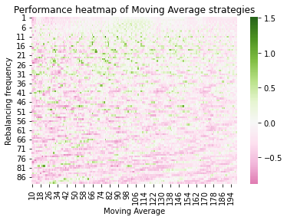

Figure 3 - 20bps trading costs and shorting allowed

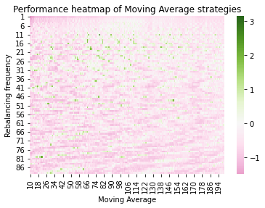

Figure 4 - No trading costs and shorting allowed

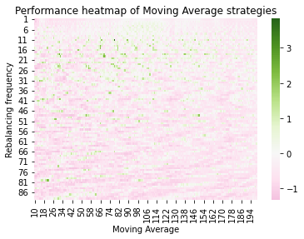

Table 1

|  |  |  |  |
| --- | --- | --- | --- |
| Strategy | Trading costs | Cumulative average performance | Standard deviation of performance between strategies |
| Rebalancing 1-100, MA 10-200, no short | 20bps | -19,53% | 24,90% |
| Rebalancing 1-100, MA 10-200, no short | 0bps | -11,42% | 26,58% |
| Rebalancing 1-100, MA 10-200, short allowed | 20bps | -41,13% | 42,80% |
| Rebalancing 1-100, MA 10-200, short allowed | 0bps | -33,99% | 46,19% |

## Summary for strategy 1

The mean-reverting moving average strategy performs better with short selling restricted and by taking a neutral position, as opposed to a short position, when the observed price is larger than the moving average price at the rebalancing dates. At the same time, there seems to be a tendency visible from the heatmaps, that the average cumulative performance improves when the strategy universe is set to choosing a rebalancing frequency between every 10th and every 30th day using a moving average price that is computed based on the trailing prices of between 30 and 200 days.

Summing all of the rows in the dataframe used in figure 1 and applying a rolling average function using the past 10 rows, shows that the highest performance has taken place from rows 17-30, which transforms into a rebalancing frequency between every 17th and every 30th day. Applying the same methodology for the columns, shows that the moving average between 135-150 days. Applying these methods to slice the dataframe results in a -4,36% cumulative average performance with standard deviation of 22,91% with 20 bps in trade costs. Without trade costs, the performance increases to +2,90% with a standard deviation of 24,67% across the 195 different strategies. The best performing scenario have a performance of +91,33% and the minimum performance being -50,44%. Even after boiling it down to 195 different strategies, there is still a large deviation in performance across the strategies. The average cumulative performance is positive up to 8bps in trading costs, after which the average cumulative performance turns negative.

Using a rolling average of 5 across rows and columns and taking the rows performing best and columns performing best, the result is a rebalancing frequency between every 20th to 24th day and a moving average calculation based on 98-102 days. This gives 25 strategies with an average cumulative performance of 18,30% with a standard deviation of 26,96%. 9 strategies had a negative performance and 16 strategies had a positive performance. This is based on 20bps in trading costs and a neutral instead of short position. The worst performance were -18,03% and the highest performance were 72,40%. The corresponding heatmap is shown below.

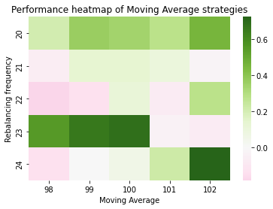

# Cross-over strategy

A cross-over strategy is a widely used momentum strategy which assumes that an observed price above the moving-average price is seen as positive momentum and a signal that the price will continue to increase in the near future. An observed price above the moving-average price will result in a buy signal corresponding to a long position in our portfolio strategy. The strategy is being evaluated with either taking a neutral or a short position when the observed price is below the moving-average price.

This is the direct opposite of the mean-reverting strategy where it was a buy signal if the observed price was below the moving-average price, as the strategy assumed this as a signal for the price to revert to its long-term mean instead of having negative momentum.

## Test results

The first test result can be seen from figure 5 with the model assuming 20bps in trading costs and a neutral position when the observed price is below the moving average price. The cumulative average performance across all strategies, ranging from using a moving average price calculated from 1 to 200 days, is -86,82% with a standard deviation of 32,76% between the performance of the strategies. No single strategy yielded positive performance.

The second test result, which is evidence from figure 6, is using the same assumptions as the previous model, but without any trading costs. The cumulative average performance improved to -48,01% with a standard deviation of 13,57%. A couple of the 199 strategies yielded positive performance, but without any clear tendency which could lead to sustainable alpha.

The third test result, which is evidence from figure 7, is using the same model assumptions but with 20bps in trading costs and a short position being taken, as opposed to a neutral, when the observed price is below the moving-average price. The cumulative average performance drops to -116,14% with a standard deviation of 24,96%. No single strategy yielded positive performance.

The fourth and final test result is identical to the third test, except no trading costs are assumed. This improves the cumulative average performance to -91,06% with a standard deviation of 18,02%. Still no single strategy yielded a positive performance.

Figure 5 - Cross-over strategy with 20bps trading cost and no shorting allowed

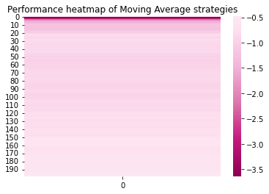

Figure 6 - Cross-over strategy with no trading cost and no shorting allowed

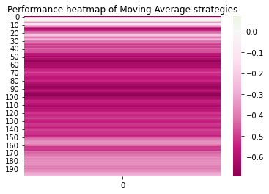

Figure 7 - Cross-over strategy with 20bps trading cost and shorting allowed

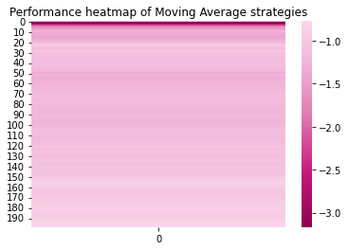Figure 8 - Cross-over strategy with no trading cost and shorting allowed

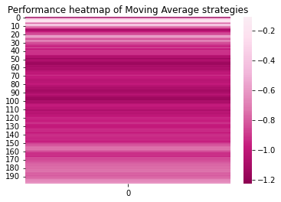

|  |  |  |  |
| --- | --- | --- | --- |
| Strategy | Trading costs | Cumulative average performance | Standard deviation of performance between strategies |
| Cross-over, MA 0-200, no short | 20bps | -86,82% | 32,76% |
| Cross-over, MA 0-200, no short | 0bps | -48,01% | 13,57% |
| Cross-over, MA 0-200, short allowed | 20bps | -116,14% | 24,96% |
| Cross-over, MA 0-200, short allowed | 0bps | -91,06% | 18,02% |

## Summary for cross-over strategy

No model assumptions yielded a positive cumulative performance, with only a couple of scenarios yielding positive performance in the setting without trading costs and no short selling allowed.

If an investor were to deploy a cross-over strategy the chance of creating alpha is approximating to zero, and the chances of sustainable alpha being even lower.

The strategies using a neutral position as opposed to a short position when the observed price were below the moving average price yielded best performance out of the models tested.

# Golden/Dead cross strategy

The Golden/Dead cross strategy is also a momentum based strategy where a short-term and a long-term moving average price is calculated. In case the short-term moving average price is above the long-term moving average price, the security is believed to have positive momentum and a long position is taken in the security. On the other hand, in case the short-term moving average price is below the long-term moving average price the security is believed to have negative momentum and a neutral or short position is taken.

In case the short term moving average is calculated using more days than the long-term, then a long position is taken when the long term moving average is above the short-term moving average and a neutral or short position is taken when the long-term moving average is below the short-term moving average. It can be argued that this is close to a strategy assuming mean-reversion, with the long-term moving average acting like the long-term price which the price will revert to and the short-term moving average being the price which will revert towards the mean.

## Test results

The first test is done assuming 20bps in trading cost and taking a long position when the short-term moving average is above the long-term moving average and a neutral position if the short-term moving average is below the long-term moving average. The heatmap is shown in figure 9 and the cumulative average performance is -35,39% with a standard deviation of 27,41%

Due to rounding differences, the model often assumes a different long-term and short-term moving average price even though both the long-term and short-term moving average is calculated using the same number of days and prices. This leads to constant trading resulting in large trading costs and a diagonal line in the heatmap with severe under performance.

This visualization do however have the benefit of showing a clear distinction between the golden/dead cross strategy and an opposite mean-reverting strategy. If the short-term moving average is calculated using more days than the long-term moving average, the strategy goes long when the short-term moving average is below the long-term moving average – but the short-term moving average in the graph is actually the “long term moving average”.

The conclusion from the visualization is that a mean-reverting strategy clearly outperforms the momentum strategy of the golden/dead cross.

The second test result is done using the same assumptions but without any trading costs for rebalancing the portfolio. When eliminating trading costs it is even more evident from figure 10 that the mean-reversion part of the strategy, which is below the diagonal line performs better than the momentum part of the strategy. The cumulative average performance is still negative at -26,95% with a standard deviation of 26,58%

The third test result is done assuming 20bps in trading costs and the position taking being short, instead of neutral, when the short-term moving average is below the long-term moving average. The overall performance of the model is worse than when assuming a neutral instead of short position, as in test result one, when the short-term moving average price is below the long-term moving average price. This is measured by the cumulative average performance which is -63,42% as compared to -35,39%. There is however a slight tendency for positive performance in the mean-reversion part of the strategy heatmap, which is below the diagonal line.

This tendency becomes even more profound when assuming no trading costs as shown in figure 12. The bolded diagonal line is also gone, due to the excessive trading when the short-term and long-term moving average price is the same not being impacted by trading costs. When eliminating trading costs, the cumulative average performance increases to -57,01% with a standard deviation of 41,00%.

Figure 9 - Golden/Dead cross strategy with 20bps trading cost and short not allowed

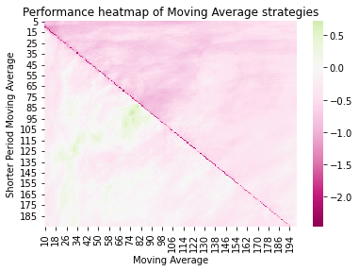

Figure 10 - Golden/Dead cross strategy with no trading cost and short not allowed

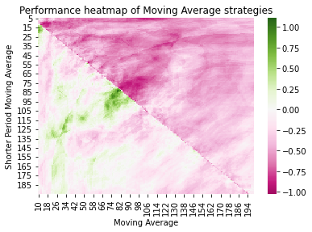

Figure 11 - Golden/Dead cross strategy with 20bps trading cost and short allowed

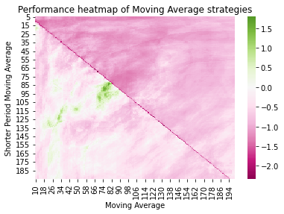

Figure 12 - Golden/Dead cross strategy with no trading cost and short allowed

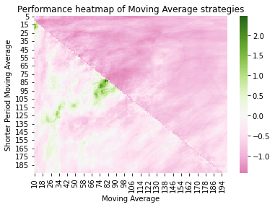

|  |  |  |  |
| --- | --- | --- | --- |
| Strategy | Trading costs | Cumulative average performance | Standard deviation of performance between strategies |
| Golden Cross, MA 10-200, short-MA 5-195 no short | 20bps | -35,39% | 27,41% |
| Golden Cross, MA 10-200, short-MA 5-195 no short | 0bps | -26,95% | 26,58% |
| Golden Cross, MA 10-200, short-MA 5-195 short allowed | 20bps | -63,42% | 39,06% |
| Golden Cross, MA 10-200, short-MA 5-195 short allowed | 0bps | -57,01% | 41,00% |

## Summary for strategy 3

It is again evident that the strategies performs better with short selling restricted than allowed. It is also quite evident that trading costs have a significant effect on performance, however the strategy as a whole still underperforms without assuming any trading costs.

Further examining the test result performing the best, which is with short selling restricted, shows that the mean-reversion part of the strategy performs significantly better than the momentum part of the strategy – with the momentum part of the strategy being the official Golden/Dead cross strategy. Examining the lower diagonal, which is the mean-reversion strategy, yielded an average cumulative performance of -16,33% with a standard deviation of 24,20%. For the upper diagonal, which is the momentum part of the strategy, the average cumulative performance drops to -53,77% with a standard deviation of 19,87%.

# Conclusion and comparing the three strategies

Across all three strategies, a couple of takeaways are evident:

* Mean-reversion beats momentum assumptions
* Restricting short-selling improves average performance
* Trading costs significantly impacts performance, but is the not the critical factor

Of the three strategies examined, the mean-reverting model with a fixed rebalancing frequency seems to yield the best average performance and the highest chance of sustainable alpha, whereas the cross-over strategy by far was the worst performing strategy.

As the case study have been performed on a single equity index and using a limited time series from 2013-2021, out of sample performance could be significantly different.

The best performing scenario, which were the mean-reversion model using fixed rebalancing frequencies between every 20th and 24th day and a moving-average price calculated based on 98-102 days are being tested out of sample. The sample contains 5 random Danish equity mutual funds with different investment strategies and the time horizon is equal to that of the in-sample index. The average cumulative performance for the 5 out of sample tests are shown below:

* Mutual fund 1: -330,66%
* Mutual fund 2: -79,16%
* Mutual fund 3: -126,17%
* Mutual fund 4: -106,97%
* Mutual fund 5: -163,68%

The model shows significant under performance in every out of sample scenario.